**Non-Invasive Assessment of Mesenteric Hemodynamics with 4D flow MRI**

1G Roberts; 2A Roldán-Alzate; 2CJ Francois; 1,2O Wieben

*Departments of 1Medical Physics, 2Radiology*

*University of Wisconsin – Madison, USA*

**Synopsis:** Chronic mesenteric ischemia (CMI) is a disease caused by inadequate blood flow to the intestines. This study investigates the use of 4D flow MRI to non-invasively asses the hemodynamics of the mesenteric circulation in patients with CMI. Flow was measured in 9 vessels before and after meal challenges for 20 CMI subjects and 6 controls. Post-prandial flow increased significantly in the supraceliac aorta, superior mesenteric artery, superior mesenteric vein, and portal vein. In the patients with CMI, this flow increase was drastically less. This demonstrates the potential for 4D flow MRI in assisting the challengin diagnosis of CMI.

**Introduction:**

Chronic mesenteric ischemia (CMI) is a rare pathology caused by a blood flow reduction to the intestines. Around 90% of cases are the result of atherosclerosis, however, other conditions, such as median arcuate ligament syndrome, may result in CMI1. Patients with CMI typically present with postprandial abdominal pain, occurring 15-60 minutes after a meal. Recurrent symptoms may result in noticeable weight-loss and fear of food. If left unrecognized, CMI has the potential to progress into life-threatening acute ischemia with bowel infarction1. Thus, a great importance is placed on the accurate diagnosis of CMI. This has traditionally been accomplished by invasive interventional angiography and duplex ultrasonography, but evaluation and visualization of the mesenteric vasculature can be difficult. 4D flow MRI has previously been proposed to anatomically and functionally evaluate mesenteric vasculature2,3. This abstract further expands on the use of 4D flow MRI for quantifying mesenteric hemodynamics and assessment of both portal venous and arterial flow in the major vessels of the upper abdomen.

**Methods**: In this IRB-approved and patient-compliant study, 20 subjects (age range 21-86y, mean = 49y, Females = 13) presenting with symptoms of mesenteric ischemia and 6 healthy subjects (age range 31-46y, mean = 39y, Females = 2) were imaged on a 1.5T scanner (Discovery MR 750, GE Healthcare, Waukesha, WI) and a 3.0T scanner (Discovery MR 750, GE Healthcare, Waukesha, WI). For all subjects, 4D PC MR data were acquired before and after a meal challenge using 5-point PC-VIPR acquisition4,5 with full volumetric coverage of the upper abdomen: imaging volume: 32x32x24cm spherical; 1.25mm isotropic resolution; TR/TE = 6.4-8.4ms/2.2-2.5ms; intrasvacular contrast agent (0.03mmol/kg of gadofosveset trisodium (Lantheus, N. Billerica, MA)); with retrospective ECG and respiratory gating. Pre-prandial imaging was performed after 5 hours of fasting. After the first scan, subjects orally ingested 574 mL EnSure Plus® (Abbot Laboratories, Columbus, OH) and scanning was continued 20 minutes after ingestion. 3D vessel segmentation from the PC data was performed using Mimics (Materialize, Leuven, Belgium). Ensight (CEI, Apex, NC) was used for anatomical assessment and flow visualization (Figure 1-2). Cut planes were placed in 6 arterial vessels: supraceliac aorta (SCAo), infrarenal aorta (IRAo), celiac artery (CA), superior mesenteric artery (SMA), right renal artery (RRA), and left renal artery (LRA). In addition, planes were placed in 3 portal vessels: splenic vein (SV), superior mesenteric vein (SMV), and portal vein (PV). These cut-planes were exported to a customized software package that allowed for temporal segmentation throughout the full cardiac cycle. Hemodynamic parameters were then analyzed for each subject. Statistical analysis was performed using paired t-tests (between pre- and post-prandial states) as well as a two-sample t-test (between groups).

**Results:** 4D flow data were successfully obtained for all 26 subjects. In response to the meal challenge for the control group, flow in the SCAo increased on average by 18% (p = 0.010), SMA increased by 52% (p = 0.014), SMV increased by 59% (p = 0.003), and PV increased by 47% (p = 0.001). The ischemia group also saw average increases in flow: SCAo 6% (p = 0.078), SMA 18% (p = 0.026), SMV 40% (p = 0.00004), and PV 27% (p = 0.00012). In addition, there was a 14% decrease in the RRA flow values (p = 0.033). Cross comparing the flow difference between both groups showed a statistically significant difference in meal challege responses, specifically, the ischemia group showed less change in flow after a meal in the SCAo (p = 0.029, effect size = -1.079), SMA (p = 0.004, effect size = -1.48), SMV (p = 0.003, effect size = -1.533), and PV (p = 0.002, effect size = -1.657). The other vessels measured (IRAo, LRA, RRA, CA, and SV) did not show statistically significant meal response differences.

**Discussion:** While the control group showed a greater change in flow in response to the meal challenge, the overall change in flow for the ischemia group was significantly less. This is most likely due to the intrinsic pathology that is preventing the vessels from supplying the appropriate amount of blood flow to the abdomen.

**Conclusion:** This study demonstrates the feasibility of using 4D flow MRI to non-invasively and comprehensively assess the functional response to a meal challenge in patient’s with possible mesenteric ischemia. Additionally, complete anatomical coverage of all mesenteric vessels could further aid in diagnosis. In summary, this tool can be used to quantitatively and qualitatively aid in the difficult diagnosis of mesenteric ischemia.

**References:**

1. Wilkins LR, Stone JR. Chronic mesenteric ischemia. *Tech Vasc Interv Radiol*. 2015;18(1):31-37. doi:10.1053/j.tvir.2014.12.005.

2. KC Li, Hopkins KL, Dalman RL CS. Simultaneous measurement of flow in the superior mesenteric vein and artery with cine phase-contrast MR imaging: value in diagnosis of chronic mesenteric ischemia—work in progress. *Radiology*. 1995;194(2):327-330.

3. Roldan-Alzate A, Frydrychowicz A, Said A, et al. Impaired regulation of portal venous flow in response to a meal challenge as quantified by 4D flow MRI. *J Magn Reson Imaging*. 2015;42(4):1009-1017. doi:10.1002/jmri.24886.

4. Gu T, Korosec FR, Block WF, et al. PC VIPR: A high-speed 3D phase-contrast method for flow quantification and high-resolution angiography. *Am J Neuroradiol*. 2005;26(4):743-749. doi:26/4/743 [pii].

5. Johnson KM, Lum DP, Turski PA, et al. Improved 3D Phase Contrast MRI with Off-resonance Corrected Dual Echo VIPR. 2008;60(6):1329-1336. doi:10.1002/mrm.21763.Improved.

**Figures:**

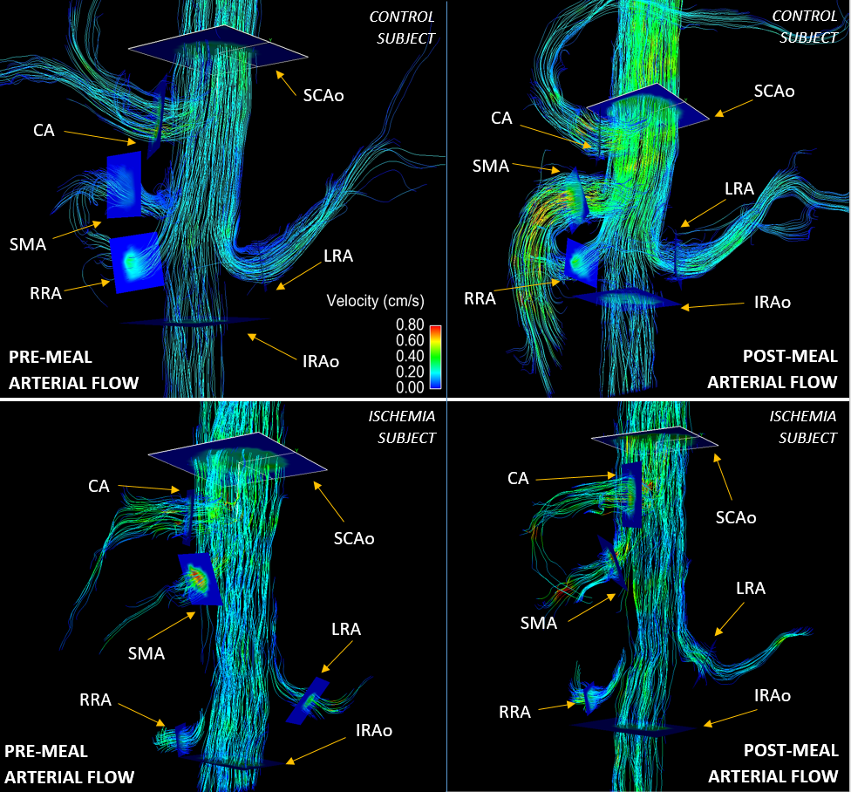

Figure 1: Arterial streamline images for a control subject and an ischemia subject for both pre-meal and post-meal scans are shown. The top images show the control subject’s flow response to a meal challenge. The velocity scale and number of streamlines is equivalent for all 4 images. The bottom images show the ischemia subject’s flow response to a meal challenge. Overall, this ischemia subject showed a reduced flow response after a meal, which is representative of the entire ischemic cohort.

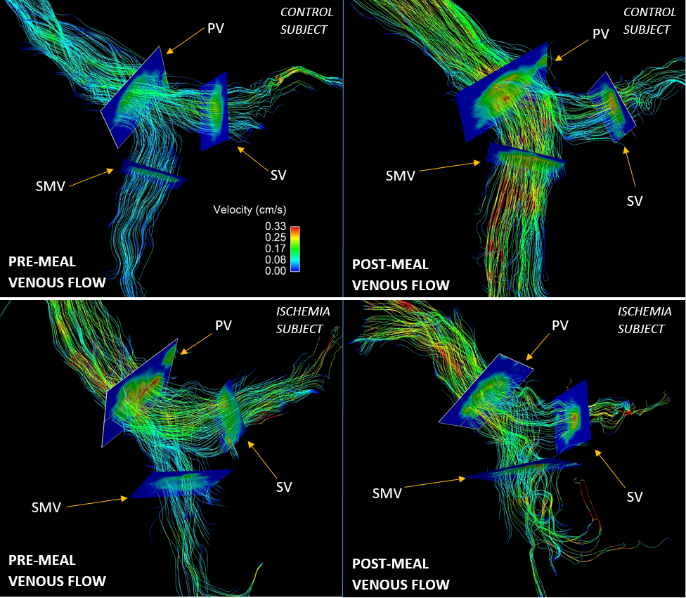

Figure 2: Streamline images of the venous system for a control subject and an ischemia subject before and after a meal challenge are shown. The top images show the control subject’s flow response to a meal challenge. The velocity scale and number of streamlines are kept constant for all images above. The bottom images show the ischemia subject’s flow response to a meal challenge. This, again, demonstrates the reduced flow response to a meal challenge in the ischemic cohort.

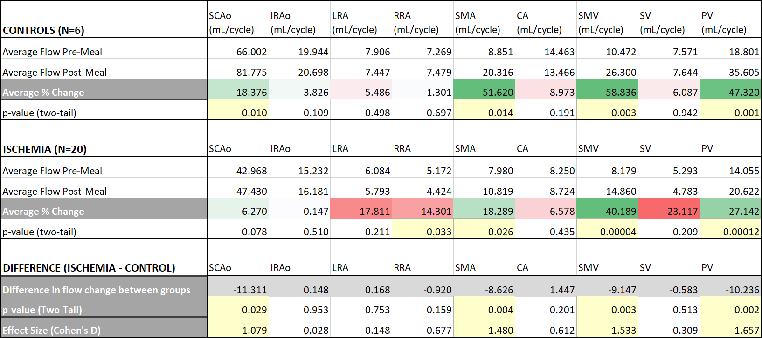

Figure 3: Paired t-tests were performed on the pre-meal and post-meal flow values for each individual group. The control group showed an average blood flow increase in the SCAo, SMA, SMV, and PV. The ischemic group showed an average flow increase in the SMA, SMV, and PV as well as a decrease in flow in the RRA. A two-sample t-test (assuming equal variances) was performed between the average flow differences between both groups. Statistical analysis shows that there is less of an increase in flow in the SCAo, SMA, SMV, and PV for the ischemic subjects relative to the control group.

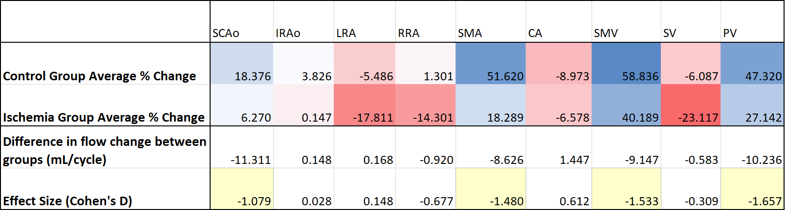

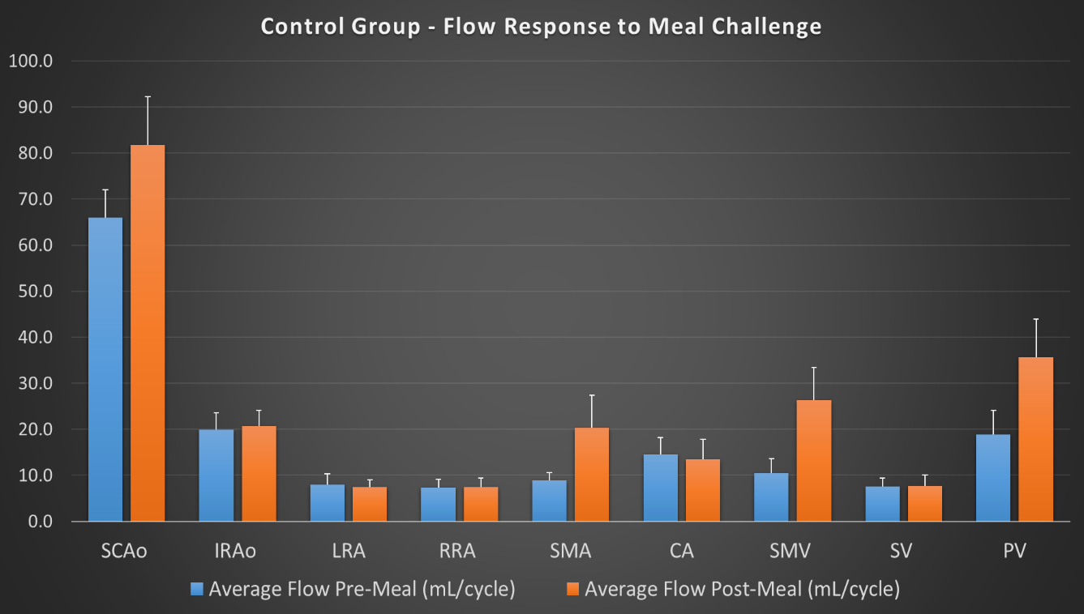

Figure 4: Bar graphs above show average blood flow in each vessel before and after the meal challenge for the control group. Standard deviation is also provided for each column. As seen in Figure 3, the most notable differences in average flow after a meal are seen in the SCAo, SMA, SMV, and PV.

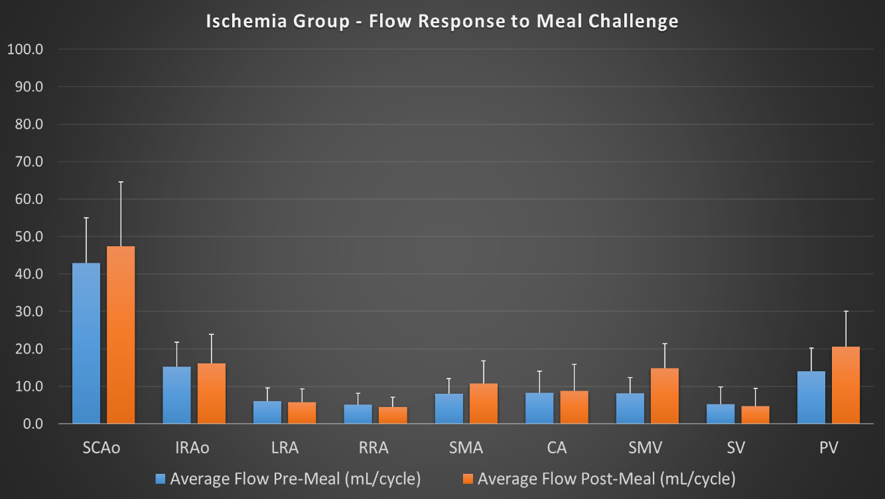

Figure 5: The bar graph above shows average blood flow for the ischemic group. Again, standard deviation is provided for each vessel. There still exists a flow difference between pre- and post-meal in the SCAo, SMA, SMV, and PV but, when comparing this graph to the control group, the change in flow in these vessels is far less drastic.